**Module 5.2 Assignment**

CSD 380 – DevOps

Darren Osier

Jeremy Ginter

6/30/2024

**Home Depot Register Closing Value Stream Map**

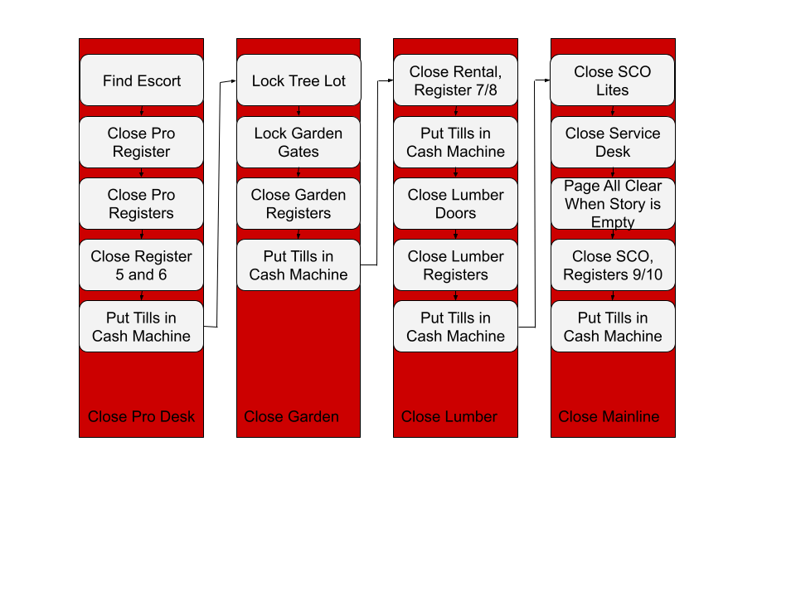

**Estimated Average Flow Time**

|  |  |
| --- | --- |
| Close Pro Desk | 25 Minutes |
| Close Garden | 15 Minutes |
| Close Lumber | 35 Minutes |
| Close Mainline | 45 Minutes |

**Estimated Cycle Time: 2 Hours**

**Optimizing my Process**

Eliminating Waste: I can reduce the time it takes to find an Escort to close the Pro Registers by planning Cashier breaks around when I will need to close the Pro Registers. This way a cashier can assist me immediately after they return from their break. I can reduce the time it takes to lock the Tree Lot Gate by having a Lot associate lock the tree lot while I lock the Garden Gate.

Workflow Orchestration: If I have enough cashiers at closing to use one as an escort, I can close part of the Service Desk before closing time, reducing the amount of time it takes to close those registers after closing.

**GitHub Repository:** <https://github.com/JDGinter/csd-380>

**References**

Knight, L. (2020, October 29). *3 easy steps for using VSM in everyday life*. ConnectALL. https://www.connectall.com/3-easy-steps-for-using-vsm-in-everyday-life/